Variable and Variable Types
Variable
A variable is any characteristic, number, or quantity that can be measured or counted
Ex.
- Age which can take values like
- Gender
- Income
- House Price
- Country of Birth
- Eye Color

Variable Types
- Numerical (Values are numbers)
  - Discrete
    - Values are whole numbers (counts)
    - Ex. Number of items bought by a customer in supermarket
    - Number of Pets, Children, etc
    - Number of bank accounts owned by a customer
  - Continuous
    - A variable that may contain any value within some range
    - Example
      - Time spent surfing a website (3.4s, 5.1s, 12.5s)
      - Total debt as a percentage of total income in the last month
      - House price (GBP 300K, GBP 100K, ...)
  - Binary Variable (is a type of discrete variable)
    - Takes one of two possible values
    - Ex. Possibility of Customer defaulting on a loan

- Categorical Variables
  - values are selected from a group of categories also called labels
  - Examples
    - Marital Status (married, single)
    - Gender (male / Female)
    - Mobile network provider (Vodafone, Airtel)

- Categorical Variable Types
  - Nominal
    - Show no intrinsic order of the labels
    - Example
      - Country of Birth (Argentina, England, Germany)
      - Postcode
  - Ordinal
    - Here categories can be meaningfully ordered
    - Examples
      - Students grade in exam (A, B, C, D or F)
      - Days of the week (Monday=1 and Sunday = 7)
  - Date / Time
    - Can take the value of date or time or both
  - Special Cases
    - Variables where categories are encoded as numbers
      - Gender may be coded as 0 for males and 1 for females
    - ID Variables: number that uniquely identifies an observation
- Mixed Variables
  - Contains strings and numbers as values

Variable Characteristics
Missing Data
- Lack of information or absence of data for some observations within a variable
- Causes:
  - Data values were
    - forgotten / lost,
    - Doesn’t exist, or
    - not stored / Not found / Not identified properly
  - Mechanisms that lead to missing data – understanding this cause helps in choosing the right imputation technique to mitigate it
    - MCAR – Missing data Completely At Random
      - The probability of being missing is the same for all the observations
      - There is absolutely no relationship between data missing and any other values, observed or missing, within the dataset
      - Disregarding these cases would not bias the inferences made
    - MNAR – Missing data Not At Random
      - Is MNAR if there is a mechanism or a reason why missing values are introduced in the dataset
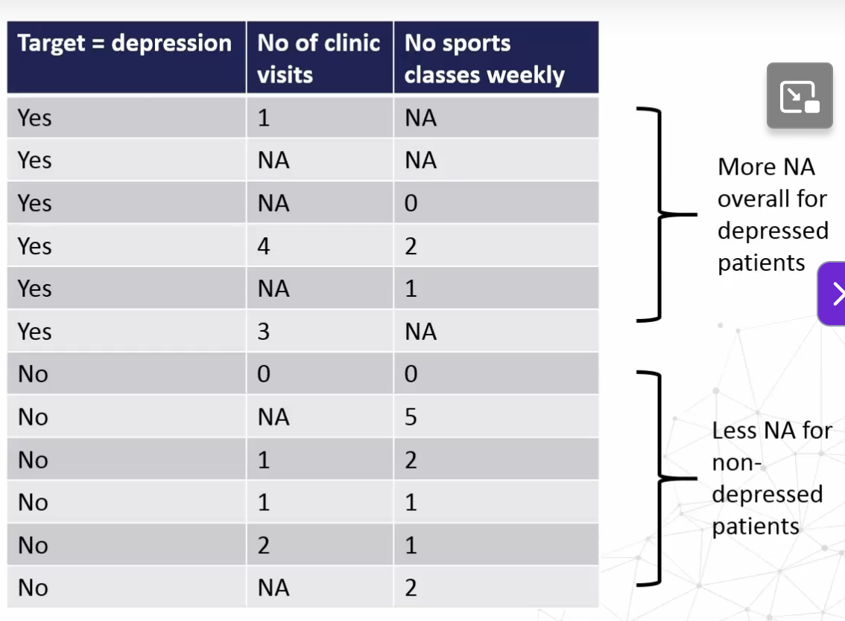
    - MAR – Missing data at Random
      - The probability of an observation missing depends on available information
      - For ex. In a Survey including men and women, As per the data collected, it can be inferred as women (maybe even of a certain age) are more prone to not divulging their weight compared to men of similar age group.
So, when proceeding to process the data considering gender too might help control the bias for missing information
- Impact
  - Libraries like scikit-learn does not support missing data
  - Missing data imputation may distort variable distribution
  - Affects all ML models
Note: To understand the mechanisms or underlying causes that are source of missing data, it is always a good idea to understand the methods of data collection as much as possible, to decide how best to engineer features.

Categorical Variables
- Variables contain strings instead of numbers

Cardinality
- The values of a categorical variable are selected from a group of categories called labels
- The number of unique / different labels is known as cardinality
- Cardinality of Gender (Male/ Female) is 2
- Impact of cardinality
  - String labels representation are incompatible with libraries like SciKit-learn – so convert/ encode them to numbers
    - Different encoding techniques may impact feature space and feature interactions
  - Highly cardinal variables may lead to uneven distribution between train and test datasets
    - Some labels may appear only in training set or only in test set
  - overfitting in tree-based algorithms
    - variables with too many labels tend to dominate over those with fewer labels, particularly in tree-based algorithms
    - A big number of labels within a variable may introduce noise with little, if any, information
    - Reducing cardinality may help improve model performance.

Rare Labels

Variable Distribution
- Normal, Skewed and others

Outliers
- Unusual and unexpected values

Linear Model Assumptions
- Do the variables fulfil the assumptions

Variable Magnitude
- Scale of different features

